Candidate code:00040-0226

Personal code: gnf681

International Baccalaureate Mathematics Higher Level Internal Assessment

Obtaining a formula for the sums of powers

**Introduction**

In IB Mathematics, we are introduced to the formulas for the sums of powers of natural numbers in summation, and use them in Riemann sums when learning calculus and in induction proofs. We study the formulas for powers up to 3, and can derive the formula for the sum from 1 to n of k using Gauss’ sum trick for 1 + 2 + 3….n, but we are not taught the formulas for the sums of k4, k5, and so on.  Knowing how to derive these formulas(closed expressions) for increasing powers of k would be useful in mathematics, for example a number of conjectures or theorems such as Fermat’s Last Theorem10,  and the Beal conjecture11.  Hence, I wanted to find out how to find a formula for at least the sum of the fourth powers of the first n natural numbers.

There have been many mathematicians who have attempted to compute closed expressions for sums of powers. Johann Faulhaber,  a German mathematician, computed closed expressions for sums of powers up to 17 in the 17th century1 .However, a general formula was only established when the Bernoulli numbers were found, which are a set of numbers that occur in many areas of mathematics2. Particularly, it appears in a formula that expresses the relationship between the summation of a function and its integral known as the Euler-Maclaurin formula3 as it was discovered independently by both mathematicians.

In this exploration, I will investigate the intuition behind this formula using Riemann sums, attempt to derive it through Taylor expansions and show the relationship between the Bernoulli numbers and the coefficients that appear in the formula. Finally, I will use the formula to obtain a closed expression for the sum of the fourth powers of the first n natural numbers, i.e

**Riemann sums**

The Riemann sums use sums of rectangles to approximate the area under a curve - its integral4. There are two types of Riemann sums - the **left** and **right** Riemann sums, shown in Fig.1 and 2 respectively.

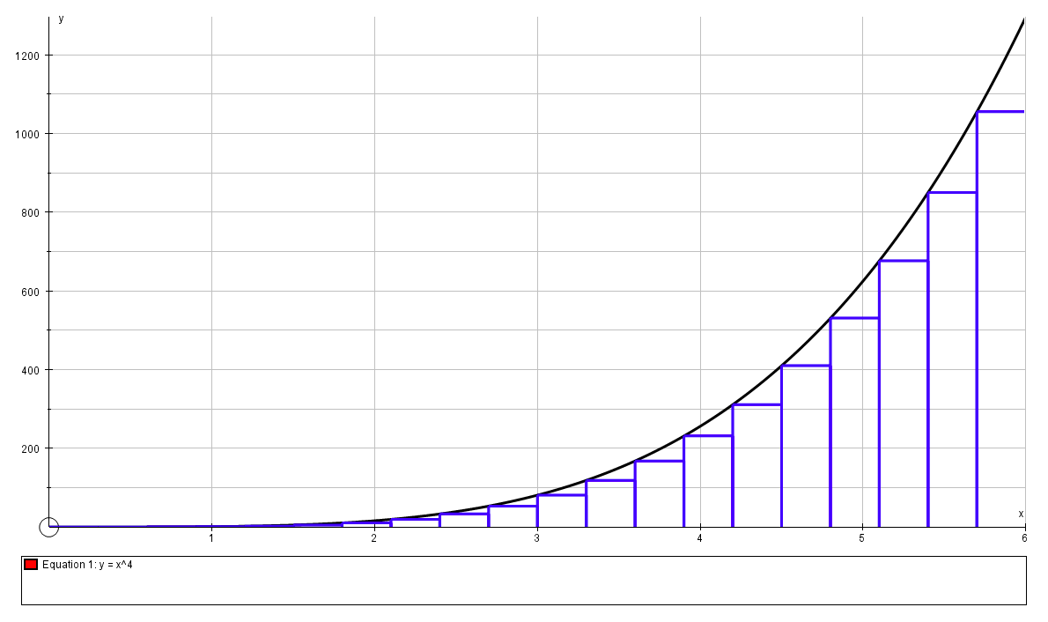

*Fig.1 Left Riemann sum with 20 divisions from 0 to 6, under the function*

*Source: Autograph*

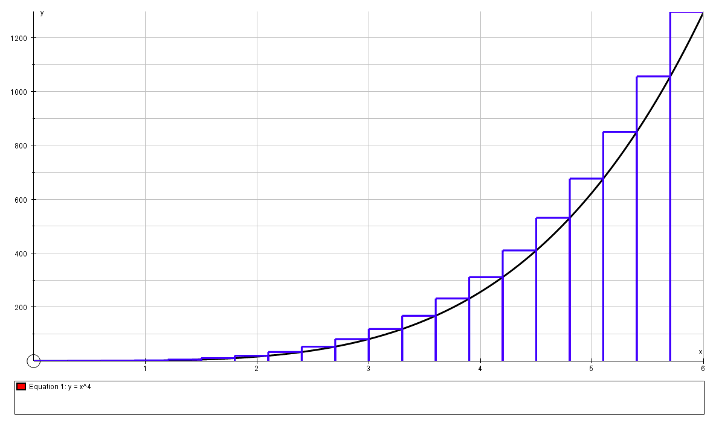

*Fig.2 Right Riemann sum with 20 divisions from 0 to 6, over the function*

*Source: Autograph*

As we can see from the screenshots, the left Riemann sum(the sum of all the rectangles under the curve) will be equal to a quantity **lower** than the actual area of the curve due to the empty space between the curve and the rectangles. Similarly, the right Riemann sum will be equal to a quantity **higher** than the actual area of the curve. However, we will look at the right Riemann sum as it will allow us to get to an expression involving the sums of powers from 1 to n when trying to express the area under the curve.

We can express this approximation of the area as a summation. An example is given in the screenshot below for .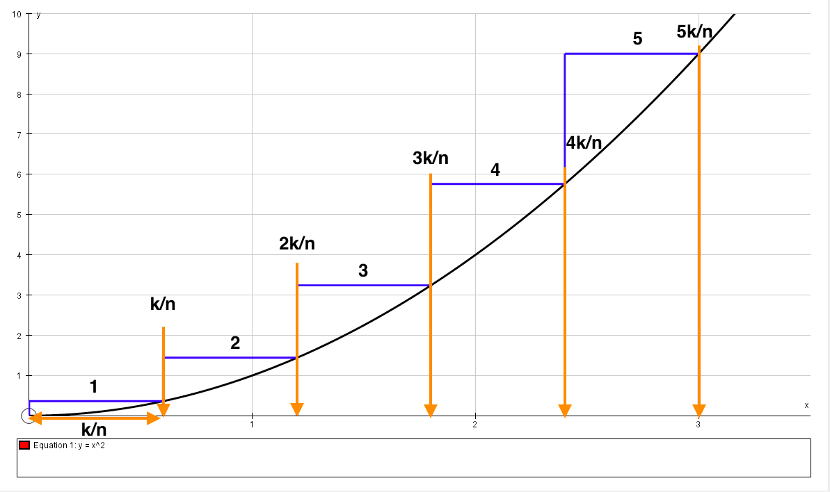

*Fig.3 Right Riemann sum for the curve* , *with n = 5 divisions or rectangles and k = 3. Source: Autograph*

The number of rectangles we are using in the approximation can be denoted as n, and the value to which we want to find the area of the curve can be denoted as k. In Fig.3, n = 5, and k = 3. As we can see in the figure, the width of each rectangle is just (in this case ) and the height of the rthrectangle is (here r goes up to the number of rectangles, 5 or n).  Hence, the area of the rth rectangle Sr is just:

The area under the curve by the Riemann sum is then just the sum of the rectangles up to the nth rectangle:

=

Since ,

=

As n , leaving k fixed, the width of the rectangles used in the sum decreases, making the sum of their areas increasingly closer to the true area under the curve of the integral: